Statement of Work

Grainger PLC
Salesforce - HomeLet Integration

Version 1.1
April 21, 2023
Contents
1 Statement of Work 3
1.1 Summary 3
1.2 existing salesforce integrations 3
1.3 New integrations 3
1.4 References 5
1.5 Project Objectives 6
1.6 Responsibilities 6
1.7 Project Administration 7
2 Exclusions & Limitations 8
3 Cost and timelines 9
3.1 timeline 9
3.2 development Costs 9
4 Go-Live and Support 10
5 Acceptance 11

Statement of Work

Summary
Grainger PLC has an existing Lead to Lease process implemented within their Salesforce org. As part of this process there is an existing point-to-point API integration between Salesforce and RightMove that facilitates the lease referencing process. Grainger PLC have taken the decision to move to the HomeLet lease referencing service instead of RightMove and need to make various changes to the relevant integrations.
The following Statement of Work (SOW) describes the development work required to update Grainger PLC’s Salesforce org to integrate to the HomeLet lease referencing service.

existing salesforce integrations
A 4-step, point-to-point integration has been implemented for Grainger PLC's current referencing solution as below:

- Ordering REST API callout from Salesforce to RightMove

- 1A: Order a new reference (from a Salesforce Opportunity by sending Opportunity and selected related Contact Roles)

- 1B: Cancel a reference order (from a Salesforce Opportunity) by sending a cancellation request from the Opportunity level

- 1C: Add applicants to an existing reference order (from a Salesforce Opportunity Contact Role level) if there is a currently active order

- 1D: Cancel one specific applicant on an existing reference order (from a Salesforce Opportunity Contact Role level) if there is a currently active order

- API callout from Leasing Portal to Salesforce using a Connected App to query Salesforce Opportunity Contact Roles to retrieve the RightMove frame URLs for every Contact Role

- Custom User Interface (Lightning Component) to handle authentication and expose RightMove Tracking Screen via an iFrame

- Webhook (API callout) from RightMove to Salesforce to update referencing status

New integrations

The future state using the HomeLet referencing service is shown in Figure 1 below. Integrations are annotated with 1A, 1B, 1C, 1D, 2 and 4 corresponding to integration numbering in 1.2 above. Integration 5 is a new integration not itemised in the list of current integrations above. 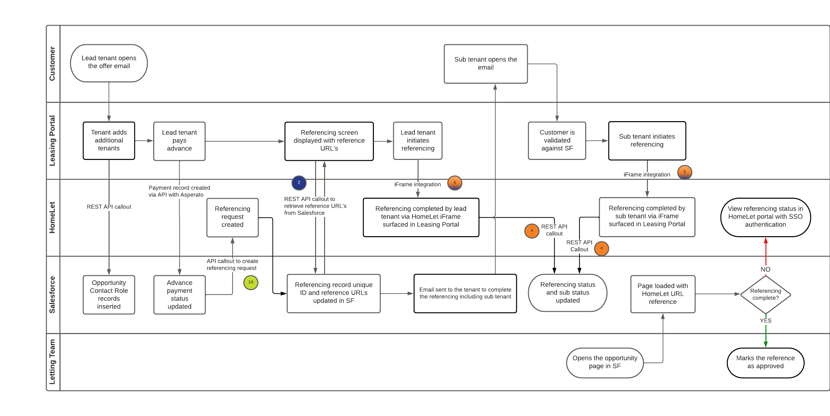
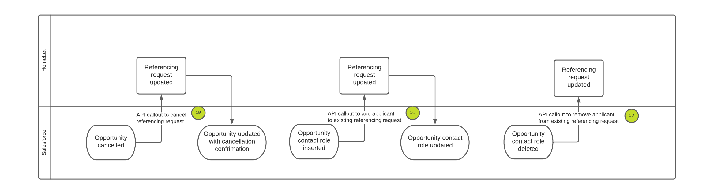

Figure 1 Future State Flow Diagrams
Changes will be required to be made as indicated below with colour coding to indicate responsibility for each item.

#1 Ordering REST API Callout from Salesforce to HomeLet | #2 API Callout from Leasing Portal to Salesforce via Connected App | #3 Expose referencing status in Salesforce | #4 API callout from HomeLet to Salesforce to update referencing status | #5 iFrame integration to expose HomeLet referencing process in Leasing Portal
Update endpoints and authentication callouts for 1A,1B,1C and 1D | Connected App setup (should already be done for current state) | Existing iFrame/Lightning Web Component removed from UI | Setup new Connected App for HomeLet | New integration to be developed on Leasing Portal
New record triggered flows to initiate invocable actions for 1A,1B,1C and 1D | Support for Connected App and API queries if required (minimal, if any, changes should be required to existing integration) | Update opportunity with URL with deeplinking to support SSO to HomeLet portal | Support for Connected App and API queries if required | Develop & support iFrame integration to HomeLet
Update invocable actions for HomeLet JSON structure and return values | Validate queries used to retrieve data from Salesforce (minimal, if any, changes should be required to existing integration) |  | Develop API callouts (including authentication) triggered within HomeLet to update Salesforce with referencing status
Update to existing logging framework to incorporate updated integrations
Apex test code to cover new/updated Apex code
Config setup to allow metadata driven switching between HomeLet and RightMove
Table 1Integration Changes & Responsibilities
Open Box Software | Grainger PLC Leasing Portal Development Team | HomeLet

References
- RightMove Integration Specification.pdf (2020-04-03)
- Vision+ API Documentation V r1.0.pdf
- Meeting with Scott Knight and Jaic George 2023-04-13
- Meeting with Scott Knight and Jaic George 2023-04-13

Project Objectives
Open Box will engage with key Grainger PLC stakeholders to:
- Develop the required changes in Salesforce as per Table 1 above
- Complete QA testing and deploy changes to Grainger PLC UAT environment for end-to-end testing by Grainger PLC
- Deploy changes to Grainger PLC PROD environment on successful completion of UAT
- Provide updated documentation detailing specifics of the new integrations

Responsibilities

Open Box will:
- Complete the Project Objectives detailed above.
- Provide prompt review and feedback to questions and comments from Grainger PLC.
- Make the necessary personnel available during the project as and when required, ensuring no delays occur through all phases, per scheduling set forth in Cost and Timelines and in full compliance with the Agreement.
- Provide project deliverables on-schedule and respond timeously to Grainger PLC feedback in accordance with the mutually agreed upon acceptance procedure.

Grainger PLC are responsible for:
- Providing access to the necessary Salesforce environments and other connected applications
- Making the necessary personnel available during the project as and when required, providing timely input through the various phases. Timing commitments cannot be guaranteed by Open Box if Grainger PLC personnel are not made available to the project.
- Signing off the mutually agreed upon Statement of Work.
- Providing prompt review, feedback and sign-off of project deliverables in accordance with the mutually agreed upon acceptance procedure.
- Involving the correct level of stakeholder representation during the various phases of the project.
- Providing all available supporting documentation as requested from time to time by Open Box.

Project Administration
- Resources will be contactable on email and available for meetings via conference or video calls.
- Project resources will be available Monday to Friday 9am – 6pm South African Time (GMT +02:00).
- A defined escalation path will be provided to the agreed project manager should urgent assistance be required outside of these times.
- Open Box will provide a regular report to the agreed Grainger PLC project manager which includes:
  - Overall project health.
  - Project risks.
  - Project milestones and timeline.
  - All other details required by Grainger PLC throughout the project, which will include, at a minimum, all details sufficient for Grainger PLC to assess project progress and timeliness under the agreed schedule.

Exclusions & Limitations
The following is not included in the cost or scope of this project:
- Single Sign On Authentication to HomeLet portal for Grainger PLC Salesforce users
- Additional work to support HomeLet call ins via webhook if HomeLet are unable to use the Salesforce REST/Composite API
- Travel or on-site resources as all work will be performed remotely
- End-user training, change management and adoption

Should additional work be required to deliver any of the above items or other requirements that arise during the course of the project, this will be undertaken at a FTE rate of £630 / day for a commitment of 5 or more consecutive days, or a T&M rate of £118 / hour if less than this. Any work performed on this basis will be estimated beforehand and will require prior approval from Grainger PLC and agreement on impact to timelines.

Cost and timelines

timeline

- An indicative timeline is shown below, showing an anticipated 4 week elapsed time to have the new integrations deployed to PROD. It is our recommendation that the changes be deployed to PROD in a way that the HomeLet integration can be enabled via metadata configuration, thus removing the dependency on the completion of the HomeLet iFrame integration (integration #3).

- The estimated start date of the engagement is April 2023.

development Costs

- It is estimated that this project will consume a total of 25 person days of Open Box resources, delivered as required by the roles below:

- Salesforce Technical Architect
- Salesforce Developer
- QA Tester

- Open Box will bill these days at a FTE rate of £630 / day. i.e. the total cost for the project will be £15 750

- Open Box will bill these costs monthly in arrears.

Go-Live and Support
- The Open Box project team will provide post go-live support for 2 weeks (10 working days) following the production deployment. This support is limited to issues that are classified as bugs and does not cover changes and/or enhancements.
- Following the post go-live support period, bugs and/or enhancements will be fixed or addressed by Open Box on a time and materials basis at £116 / hour. All work completed on this basis will first be estimated by Open Box and will require prior approval from Grainger PLC.

Acceptance
The parties hereto, each acting under due and proper authority, have executed this Agreement as of the day, month and year first written below.
For and on behalf of  Open Box Software |  |  | For and on behalf of  Grainger PLC
Signature: |  |  | Signature:
Name: | Sam Duncan |  | Name:
Position: | Director of Salesforce |  | Position:
Date: |  |  | Date:

